HoloLens Human Anatomy



By: Mohammad Saleh, Chase Mulder, Liam Mazure, and Lucas steerlin

Sponsor: Hunter Bridwell, Dr.Gustav Lo

Table of Contents:

Abstract:

Introduction:

Hololens Anatomical Learning Tool:

Tools used:

Languages:

Production

Stretch Goals Easy to Hard:

Issues:

Software Engineering Code of Ethics and Professional Practice:

Teamwork reflection:

Conclusion:

Major Challenges Encountered:

Future Work:

Keys to Success:

Appendix 1:

Rubric (remove when done):

## 

## 

## 

## 

.

## 

## **Abstract:**

Using augmented reality (AR) in a medical practice was once thought to only exist in science fiction movies. Our team has set out to change this long held assumption. Our project attempts to replace conventional 2D interactions of anatomical learning tools with an interactive 3D space fully viewable in the world around us. There are a few reasons why a VR medical anatomy app for the HoloLens could be considered innovative. For example it would allow medical professionals to explore the human body in a way that is not possible with traditional anatomy modeling. With a VR application, users would be able to manipulate virtual representations of the body and see how the different parts and systems work together in real time. This could be especially useful for medical training, as it would provide a more immersive and interactive learning experience.

Additionally, a VR medical anatomy app for the HoloLens could be used to help patients better understand their own anatomy and medical conditions. By providing patients with a virtual representation of their own body, doctors could use the app to help explain medical procedures and treatments in a way that is easier for patients to understand. This could be especially helpful for patients who are dealing with complex or difficult-to-visualize medical conditions. The accomplishments from our group included full body male and female models, updated user interface with dynamically changing description cards that display a short definition of the currently selected system, as well as a functioning magnifying glass to allow the user a more detailed view of the models' many layers.

Overall, a VR medical anatomy app for the HoloLens has the potential to provide a unique and engaging learning experience for medical professionals and patients alike. It could be a valuable tool for medical education and training, as well as help doctors explain medical procedures and treatments to their patients.

## **Int****roduction:**

The purpose of this project is to educate and help diagnose medical issues. Our sponsor looked at the problem his patients encountered and asked how we can use modern technology to facilitate a more accurate diagnosis. Meaning the HoloLens will be able to bring a new approach to problem solving for an abundance of doctors, patients, and students. The goal of this project was to create an educational app on the HoloLens that will show different overlays such as internal organs, muscles, and skeleton while displaying descriptions of each in tandem. The app for the HoloLens was built using Unity3D with C# scripting. The 3D Models of the internal organs were constructed in Blender. The end result is a working demo for the GVSU innovation showcase where users can put on the HoloLens and see the internal organs of their friends overlaid on top of them in mixed reality.

Utilizing the Unity game engine along with C# scripts, we were able to shape an interactive augmented reality allowing a user to explore and learn the multitude of interworking systems of the human body. The accomplishments from our group are far reaching, including full body male and female models, updated user interface with dynamically changing description cards that display a definition of the current system, as well as a functioning magnifying glass to allow the user a more detailed view of the models' many layers. We have also had the pleasure to be able to iterate off of the previous project developers' work. This means that we have inherited and continued to practice well thought out design along with other features such as a custom designed “fat slider” to change the percentage of fat visible on the models abdomen. Overall, the work our group attained had a tremendous impact on both our learning as students along with the project's physical appearance. Leaving our group excited to share our accomplishments with GVSU and our fellow peers.

# **Hololens An****atomical Learning Tool:**

#### Tools used:

* Unity
* Microsoft HoloLens
* Github

#### Languages:

* C#

# **Production**

# **Stretch Goals( Easy to Hard):**

1. Spend money on higher resolution models with more detail and color. Important organs like the heart to be prioritized. Will it lag? If deployed over IP there will be more lag vs deploying over USB. Also, the higher the resolution of the models the more lag there will be. High quality models can be found on TurboSquid.com.
2. Updated flashcard descriptions from Gus. Current descriptions are from Merriam Webster.
3. Fat slider. Use the slider functionality for something else.
4. See names of each muscle, or bone. Set up an icon system like the organ sub system to turn on and off groups of systems i.e. digestive, reproductive, and urinary systems.
5. Turn on and off magnifying glass.
6. X-ray vision. A previous patent on this uses the magnifying glass to look inside the body like x-ray vision.
7. Collaboration feature, so two headsets can be viewing and interacting with the same model.
8. Hand tracking on the AR points, so that the model moves with the person.
9. LIDAR with a phone camera to map faces to create models and textures. Take a reverse panoramic photo and upload it. Get in touch with Iris CEO david.

#### Issues:

Deploy project with exe on PC by building project for Universal Windows Platform. If there are errors building, read the “Read_ME” document. If you try to build the project for the HoloLens platform, a known error is a version error with the burst compiler that is preventing it from building. This error means the project can’t be built into a Visual Studio solution and compiled into a deployable exe on the HoloLens.

Get AR points to work when placing them on a person. This is not for stretching the model, it's more for fitting the model to the person. Our group messed up placing the AR points, so bringing back that functionality and adding more AR would map the body to the model better. Some beneficial AR points should be added for chin, knees, feet, hands, elbows, and many more.

## [Software Engineering Code of Ethics and Professional Practice](https://ethics.acm.org/code-of-ethics/software-engineering-code/):

1.01. Accept full responsibility for their own work.

* This is important because it ensures that individuals are accountable for their own performance and that they are not relying on others to cover for their mistakes or shortcomings

2.03. Use the property of a client or employer only in ways properly authorized, and with the client’s or employer’s knowledge and consent.

* The second principle is important because it helps to prevent the unauthorized use of property, which could lead to legal and ethical issues.

3.09. Ensure realistic quantitative estimates of cost, scheduling, personnel, quality and outcomes on any project on which they work or propose to work and provide an uncertainty assessment of these estimates.

* This principle prevents unrealistic expectations and potential conflicts down the line.

4.05. Disclose to all concerned parties those conflicts of interest that cannot reasonably be avoided or escaped.

* This ensures that all stakeholders are aware of any potential conflicts that may affect the project.

5.04. Assign work only after taking into account appropriate contributions of education and experience tempered with a desire to further that education and experience.

* This is important because it ensures that individuals are given work that is appropriate for their level of knowledge and experience and that they have opportunities to learn and grow in their roles.

Overall, these principles highlight the importance of professionalism, integrity, and accountability in the workplace. By following these principles, individuals can ensure that they are conducting themselves in a professional and ethical manner and that they are contributing to the success of their projects and organizations.

## Teamwork reflection:

**Chase:**

Overall, working on this project was a challenging and rewarding experience that honed my technical skills. The HoloLens is cutting-edge technology for the field and it was quite the experience playing with holograms all semester. This project led me to take on a significant amount of responsibility in working on developing an app for a medical doctor. In this project I gained a lot more experience in Unity and learned how to do virtual reality things in Unity with Maker Reality Took Kit. I really enjoyed using the HoloLens and hope to work in the field of virtual reality in the future.

**Liam:**

As a whole this project was a true culmination of the education I have received. I feel that our team worked incredibly well in communicating with one another along with our client Gustav and faculty partner Hunter. Each member was willing to take on varying responsibilities the project had to offer. This includes far more than evolving our project into its current state, but also being flexible and willing to meet regularly to discuss progress and future goals. I felt confident that I could count on each of the members to get work done when needed. Overall, this experience has elevated my confidence in working with a team to accomplish a common goal. I know that each member had something to contribute and wanted to see our team succeed.

**Lucas:**

From start to finish, I have always felt appreciative to be placed on this project. Working in Unity is something that I have been interested in for a long time, and the ability to work on such an advanced project through Unity has been a long-term goal of mine. It wasn’t until I was able to demo the application on the Hololens headset until I was truly able to imagine what this application could do to benefit the educational and scientific communities. Throughout the semester, I have greatly improved my Unity skills as well as team coordination and leadership. This project has been the closest thing I have encountered to a real-world work experience, and I hope to take what I have learned and keep growing as my career takes off.

**Mohammad:**

This was a learning curve that opened my horizon. The communication between the team and listening to the sopranos about how he wanted his product to be like. This project allowed me to get creative. I can see this project making an impact in education and creating a new approach to learning especially for the students that have a learning disability. The interactive feature will inspire learners to create or enhance said product. I learned very quickly that unity is very user friendly. There is a lot of resources out there to help you build what you want using unity.

## Conclusion:

Over the past few months our group implemented an assortment of capabilities to a previously developed 3D anatomical learning application. Utilizing our prior and learned experience with the Unity game engine and C#. We were able to construct a product that we are elated to share with our fellow students, GVSU faculty, and most importantly our client Gustav Lo and faculty partner Hunter Bridwell. This however does not mean we did not face our fair share of setbacks. We were forced to shift our plan on the fly with each new issue encountered. Working with each other to facilitate a proper solution. This project genuinely tested our ability to work well as a team and implement the many skills we have learned over our time at GVSU.

#### Major Challenges Encountered:

To start, our team had minimal experience working with Unity making the beginning stage of the project learning intensive. Along with the challenges understanding Unity and its many webs of information was working with our partner so that each member was on the same page as to what the team's goals should be and where we should focus our efforts. Due to our partner's busy schedule, communication was slow to start as the group was fine tuning a proper meeting time. As time moved on we worked to surpass these obstacles only to be met with many more. Several members of our team faced difficulties with sufficient hardware to meet the demand that Unity takes in order to run along with the abundance of data that a single Unity application requires.

#### Future Work:

Moving onward, future teams have a plethora of potential routes to take this project either continuing work on the learning application by adding new functionality to allow specific systems to be located via a search bar as an example or shifting focus to the other phase of the project concentrating on loading in CT scans from a patient allowing for a more accessible viewing experience. Ultimately this decision is up to Gustav our partner as to which direction he would like to see the next team proceed. There is an abundance of ideas and utilities that could be implemented into either phase. The question is more which one should be first.

#### Keys to Success:

Overall, our team success can be attributed to outstanding communication from every member. This allowed for ideas and just as importantly concerns to flow effortlessly between members. The team met multiple times a week and was able to update Gustav bi-weekly or as his schedule allowed. Gustav was also kind enough to provide the assistance of one of the previous team's developers to stand in on some of our meetings to answer any questions we had regarding the work he and his team had done, along with providing insight as to how we could begin to implement our goals. In the end, one individual can accomplish a limited amount on their own, but with the support of a team we were able to continue to meet our goals with each new challenge the project presented.

## Appendix 1:

# 

# 

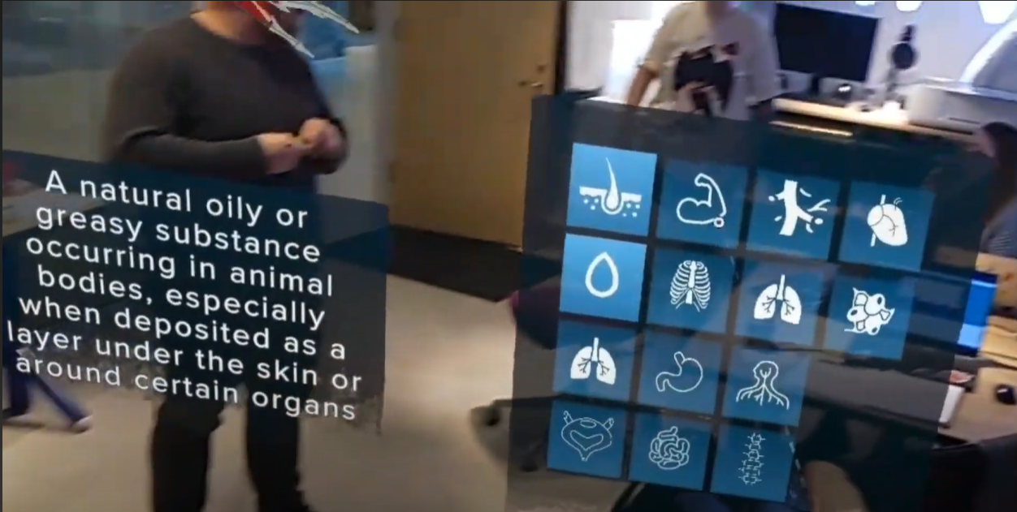

~~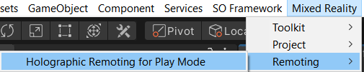~~

~~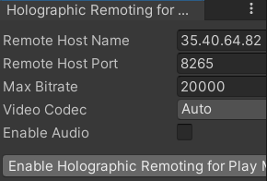~~

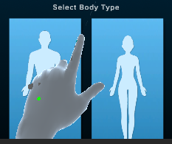

Left hand is shift right hand is space scrolling is clicking

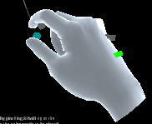

Place the AR points using the right hand and place the points in the following positions:

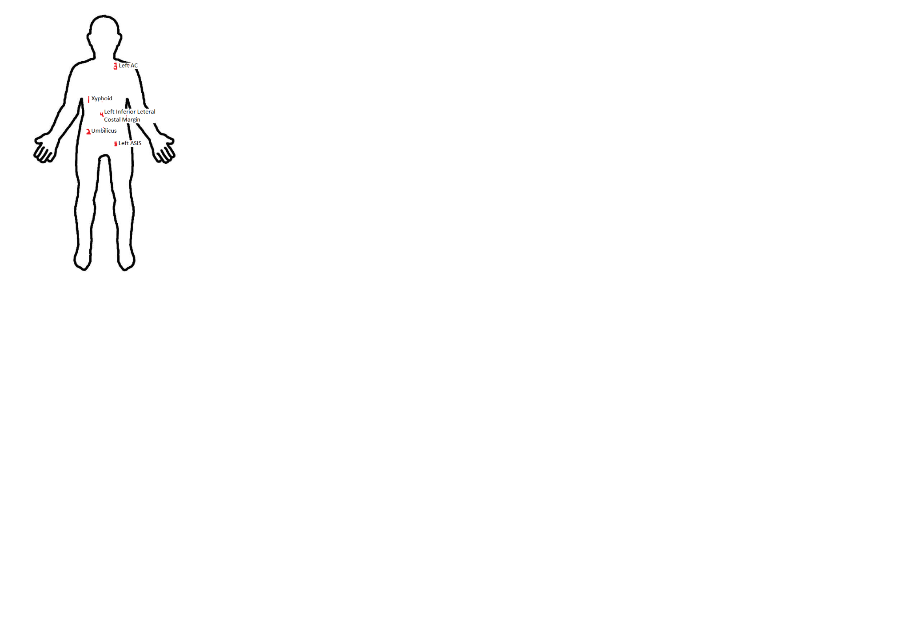

Deploy project over IP in Unity



Skin mesh of desired person.



 